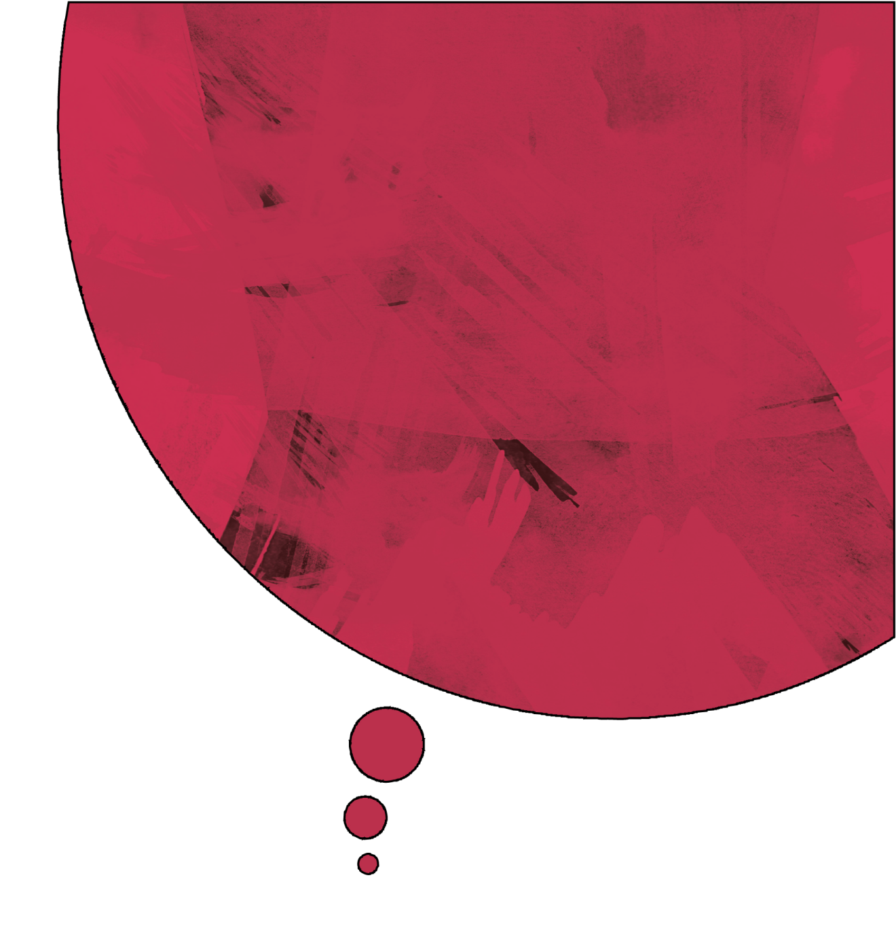

**2. Risk Factors:** high level of current stressors, substance abuse, loss, psychiatric illness.

**3. Protective Factors:** coping skills, strengths, supports, self-control.

1. **Suicide Inquiry:**
   1. **Plan** (lethality, access to means)
   2. **Intent** (motivation, impulsivity)
   3. **Behavior** (sudden change, depression, neglect of hygiene, etc.)

**Suicide Assessment 101:**

**Antidepressants:**

* Citalopram (Celexa)
* Buproprion (Wellbutrin)
* Fluoxetine (Prozac)
* Fluvoxamine (Luvox)
* Mirtazapine (Remeron)
* Sertraline (Zoloft)
* Venlafaxine (Effexor)
* Trazadone (Desyrel, Trialodine, Trazon)

**Antipsychotics:**

* Haliperidol (Haldol)
* Olanzapine (Zyprexa, Zydis)
* Quetiapine (Seroquel)
* Risperidone (Risperdal)
* Ziprasidone (Zeldox)
* Clozapine (Clozaril)

**Antianxiety:**

* Diazepam (Valium)
* Lorazepam (Ativan)
* Clonazepam (Klonopin)

**Mood Stabilizers:**.

* Carbamazepine (Epitol)
* Divalproex (Valproic Acid)
* Lithium
* Gabapentin (Neurontin)

**Remember some drugs serve more than one purpose in psychiatry and it is always important to be clear on the individual reason each pt. is taking them.**

**MENTAL HEALTH**

**Cheat Sheet**

**By Jenn MRBNSN4**

**Charting 101:**

**A – Affect:** how they look to be feeling to YOU, how this compares to what they say.

**Ex. Words**: euphoric, euthymic, bright, pleasant, labile, restricted, sad, flat, blunted.

**B – Behaviour:** how they act.

**Ex. Words:** Settled, socializing with co-pts., seclusive to self, pacing unit, gesturing, aggressive.

**C – Cognition:** how they think.

**Ex. Words:** thoughts coherent, thoughts disorganized, tangential thoughts, inability to concentrate, delusional thought content evident, admits to hallucinations (type), SI/HI (intent? plan?).

**More Detail:**

1. Appearance
2. Mood/Affect
3. Speech & Eye Contact
4. Thought Process
5. Thought Content (delusions?)
6. Perception (hallucinations?)
7. SI/HI
8. Insight

**Quick Drug Guide**